
CLEAR REFLECTION

MIRROR CATEGORY
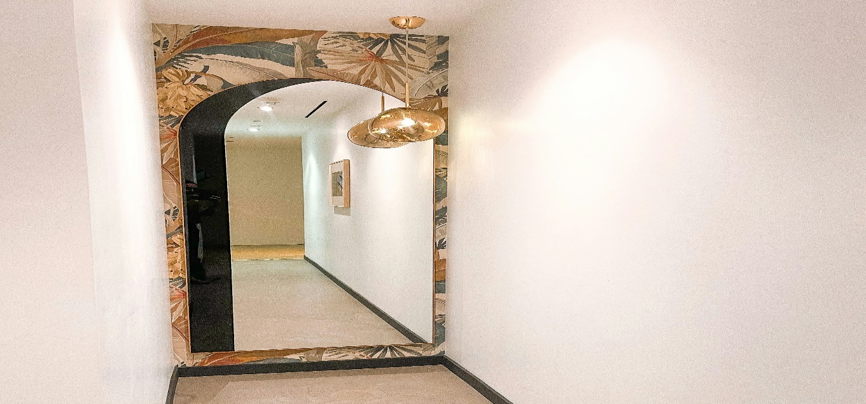
“DRAWING ROOM MIRROR”
Living room mirrors are a key design element that enhances both the beauty and functionality of the space, making the room feel more open, bright, and inviting. A well-positioned living room mirror reflects natural and artificial light, helping to create a spacious and airy atmosphere while adding depth to the interior. Whether used as a decorative wall mirror, a large statement piece, or a set of stylish accent mirrors, they bring elegance and balance to the overall décor. Living room mirrors can complement a wide range of styles, from modern and minimalist to classic and luxurious, depending on their shape, size, and frame design. They often serve as a focal point, enhancing furniture arrangements and highlighting artwork or lighting features. High-quality living room mirrors are crafted with clear, distortion-free glass to ensure a flawless reflection and long-lasting durability. Overall, a living room mirror is not just a decorative accessory but a sophisticated design feature that adds charm, light, and visual harmony to the living area.

